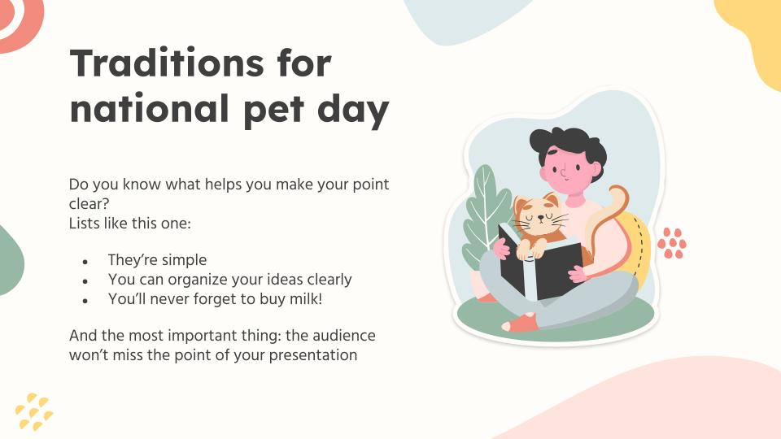

Adopt don’t Shop!

**FurEver Home**



**Adopt a Pet**

Find a pet that suits your lifestyle! Meet personally, make a bond, and adopt.

**Meet the Team!**

|  |  |
| --- | --- |
| Name | ID |
| Malak Hisham | 20221310165 |
| Rana Mostafa | 20221440972 |
| Rana Yasser | 20221466866 |
| Mariam ElMaghraby | 20221453874 |
| Nada Dhaheer | 20220203322 |
| Aya Hamed | 20221462478 |

**Project Idea**

FurEver Home is a mobile app that simplifies pet adoption by connecting prospective pet owners with animal shelters, rescue organizations, and other pet owners. It aims to make buying pets less and increase adoption since many have been rescued from horrific circumstances such as cruelty, neglect, and abandonment. Users can browse through a wide range of pet profiles, initiate the adoption process, and communicate with shelters or pet owners directly through the app. With its user-friendly interface and comprehensive features, FurEver Home aims to make finding a loving home for pets easier and more efficient.

**Design Documentation**

Data Flow Diagram:

**DFD Level 0**

**  
Final DFD**

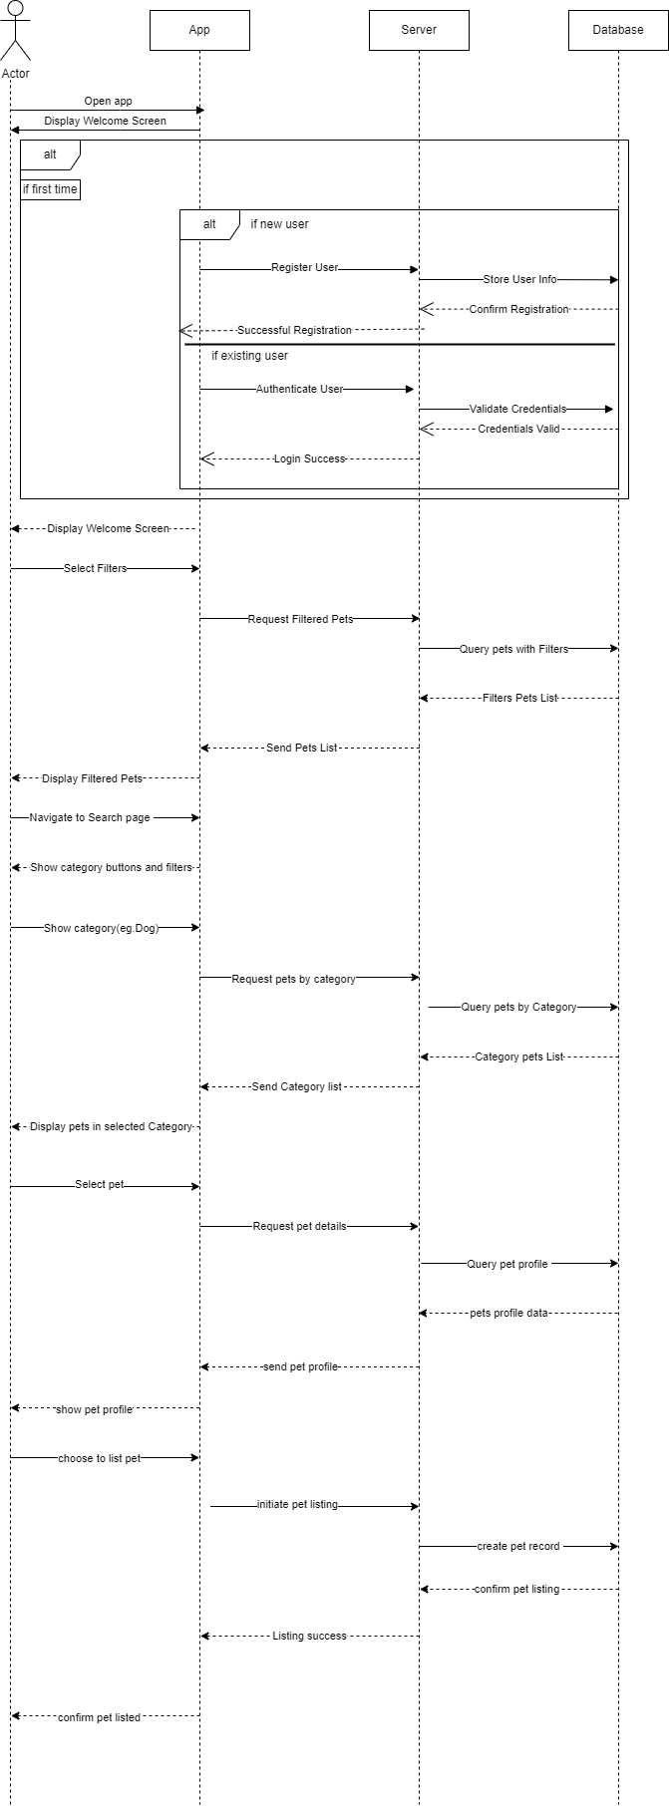Sequence Diagram:

Use Case Diagram:

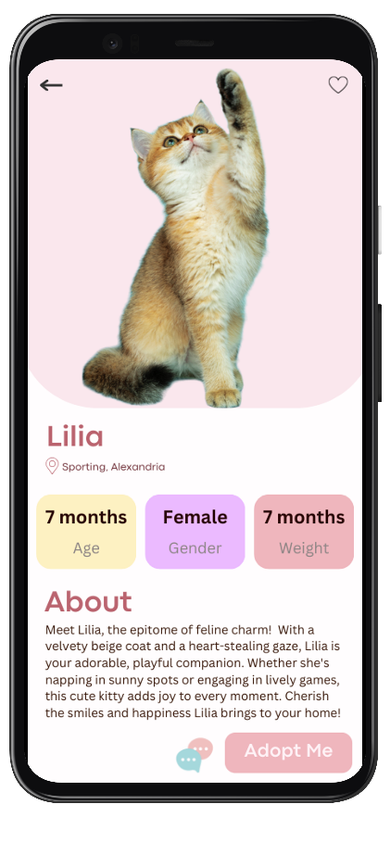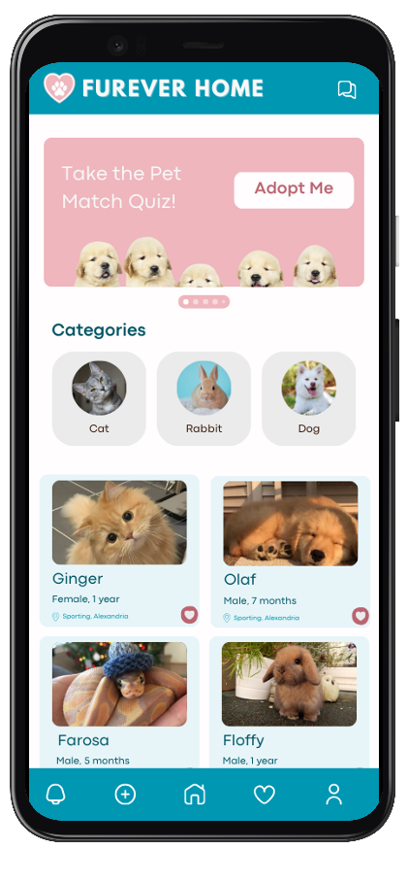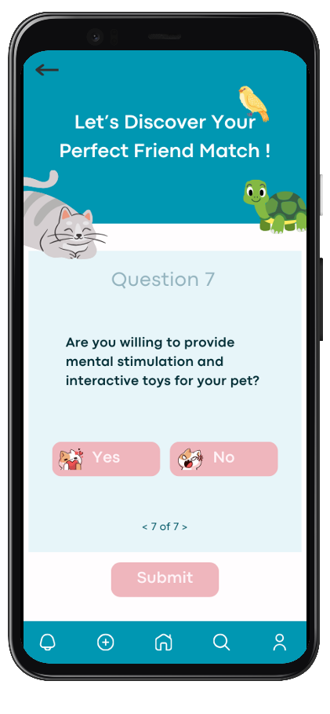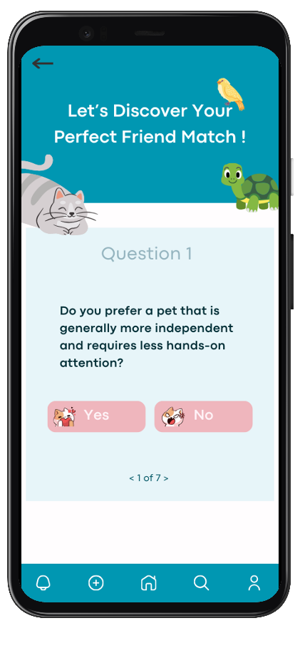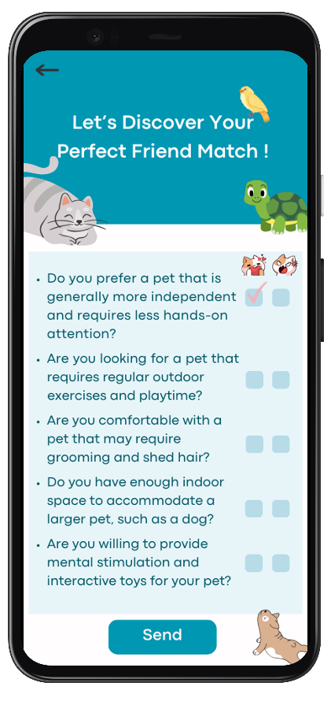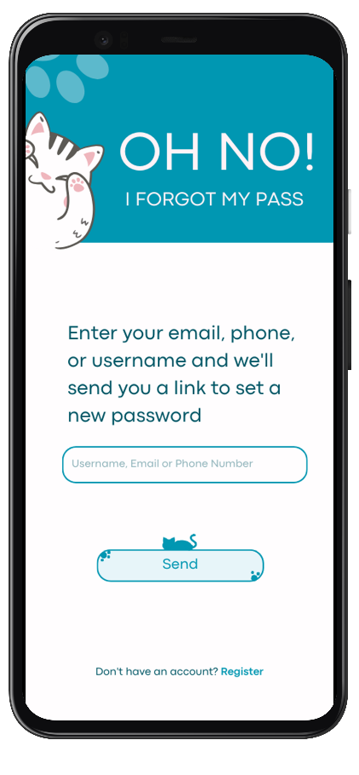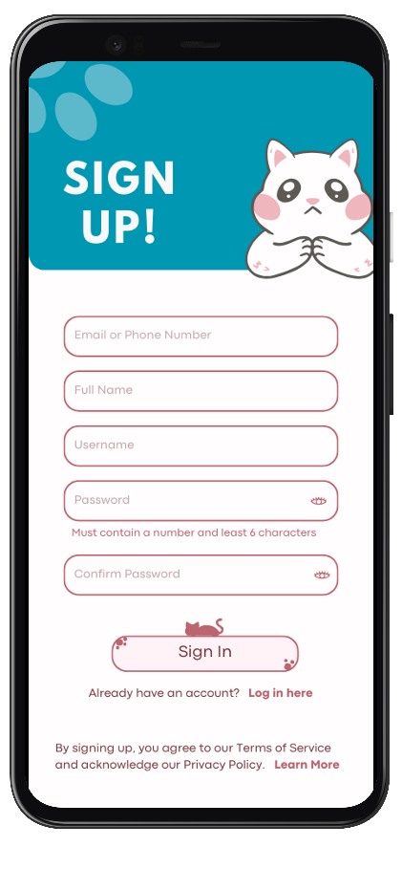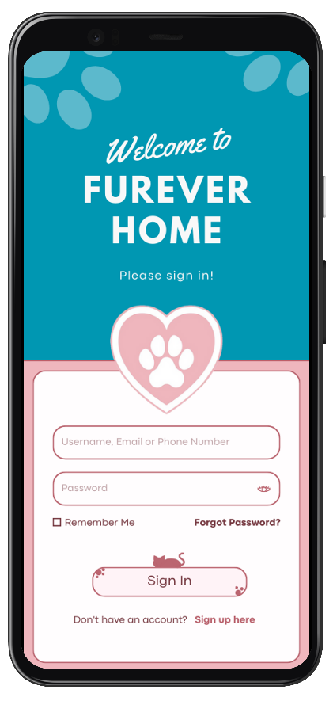**Design Concept:**

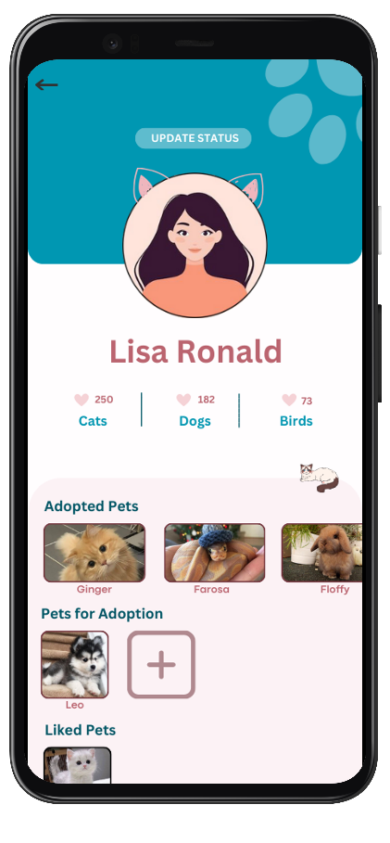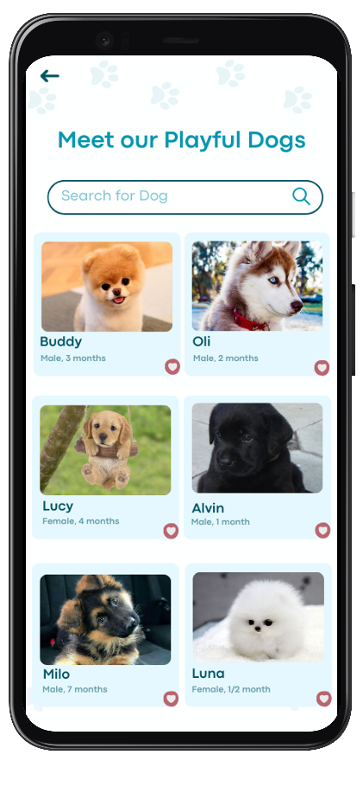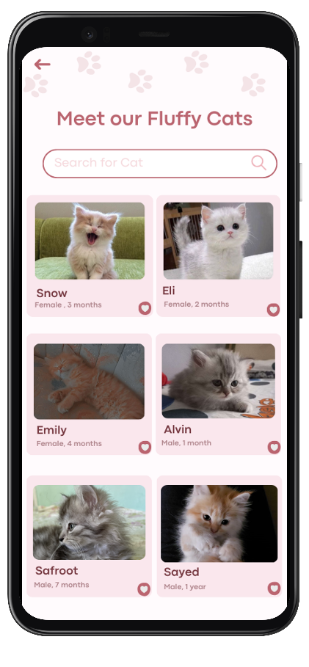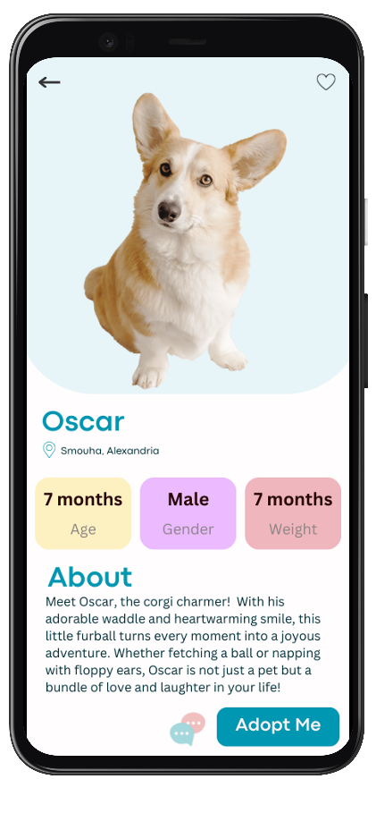

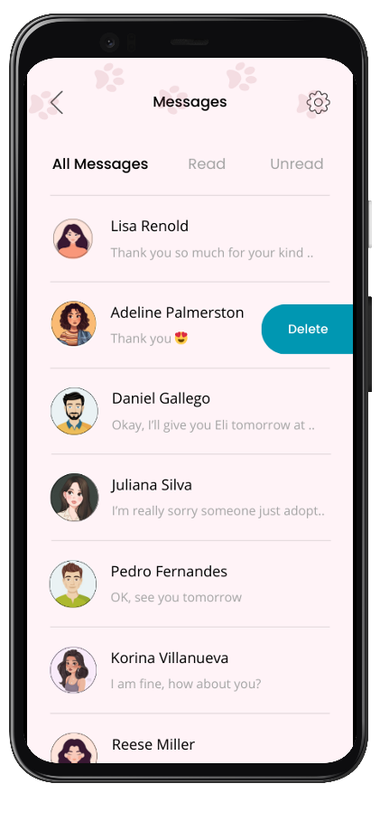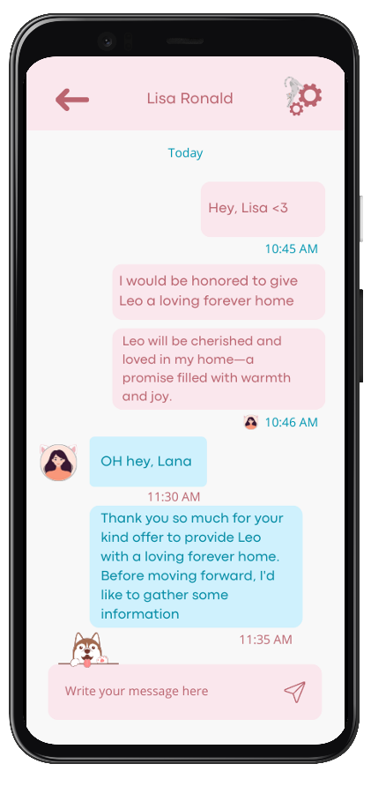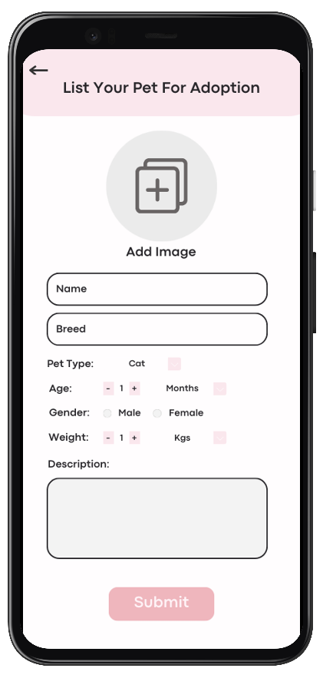

**Data Transfer Section:**

* Navigation Flow:
  + **Log In Page:** Successful login -> Home Page
  + **Sign Up Page:** Successful signup -> Home Page
  + **Forgot Password Page:** Password reset -> Log In Page
  + **Home Page:**
    - Navigation bar icons lead to respective pages.
    - Category section -> Pet Display Page
    - Featured pets -> Animal Profile Page
  + **Questionnaire Page:** Complete questionnaire -> Home Page
  + **Animal Profile Page:** Adopt button -> Adoption Form Page
  + **Pet Display Page:** Select pet -> Animal Profile Page
  + **User Profile Page:** Liked pets -> Pet Display Page
  + **List Your Pet for Adoption Form Page:** Submit -> User Profile Page
  + **Chats Page:** Select chat -> Single Chat Page
  + **Single Chat Page:** Back to Chats -> Chats Page

**Login Activity:**

Upon successful login, the Login Activity stores login session data, such as authentication tokens, securely.

Uses Intent extras to pass essential user details (e.g., username) to the Home Activity.

**Note:** Intent extras are key-value pairs that you can include in an Intent to send additional information between different components of your Android application.

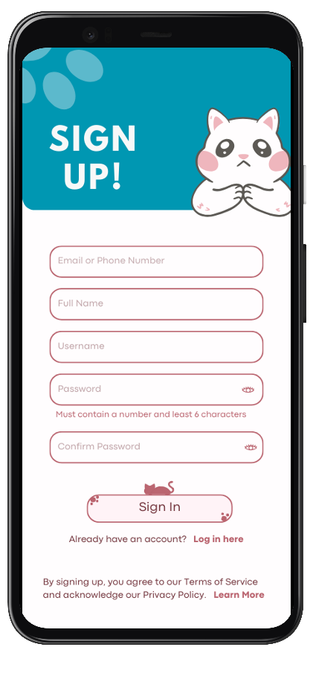

**Sign Up Activity:**

Returns newly created user data to the Login Activity upon successful sign-up using Intent extras.

Stores new user profiles securely in the database for future reference.



**Forgot Password Activity:**

Utilizes email communication to send password reset links.

Implements secure password reset mechanisms.

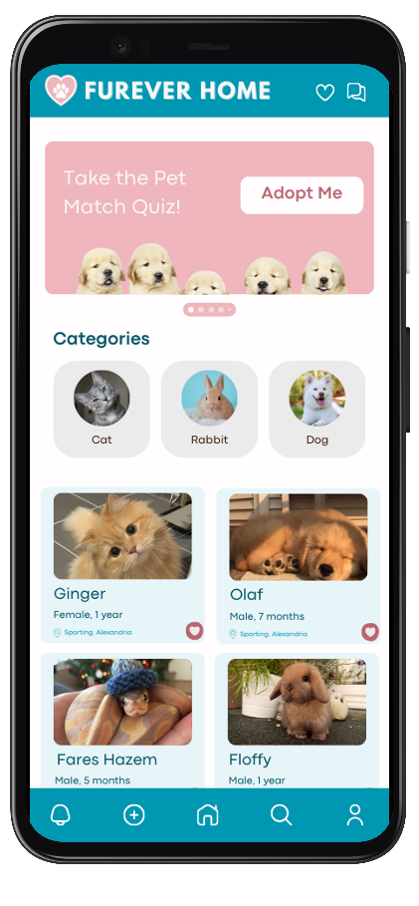

**Home Activity:**

Manages the list of available animals using ViewModel.

Observes changes using LiveData and updates the UI accordingly.

Implements search functionality to filter and display pets matching the search criteria.

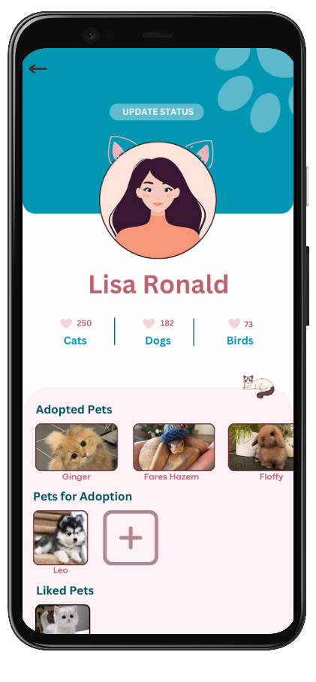

**User Profile Activity:**

Retrieves and displays user profile data from the database and shared preferences.

Aggregates likes for each animal, displays the total likes, and showcases images of liked pets.

Includes adopted pets and pets listed for adoption on the user's profile.

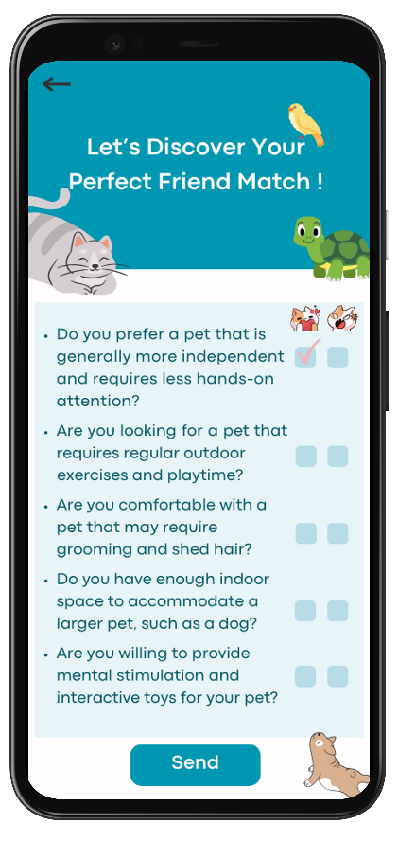

**Questionnaire Activity:**

The questionnaire consists of a series of yes/no questions designed to assess the user's personality, lifestyle, and preferences.

Captures and stores user preferences during the questionnaire for future recommendations.

The system analyzes the user's responses to identify patterns and preferences.

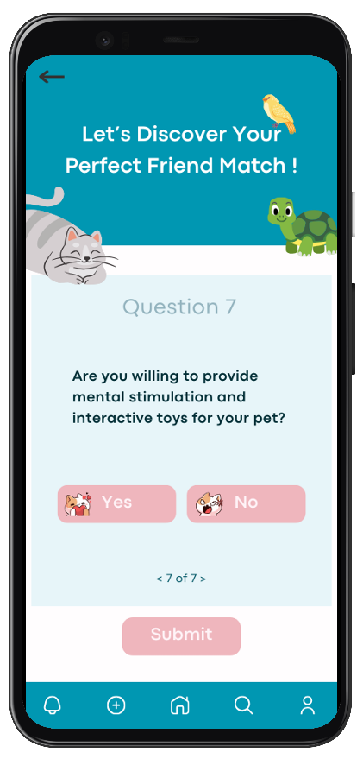

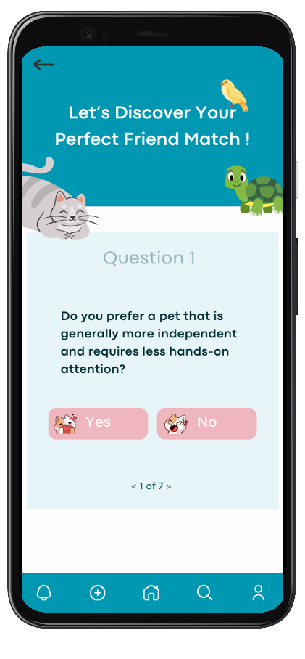

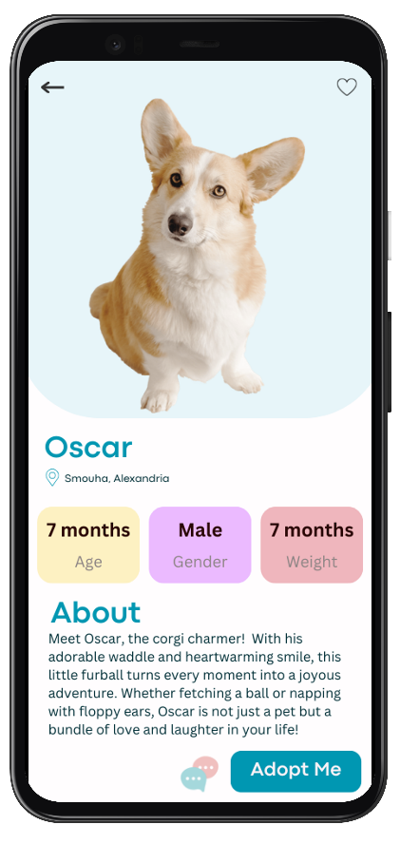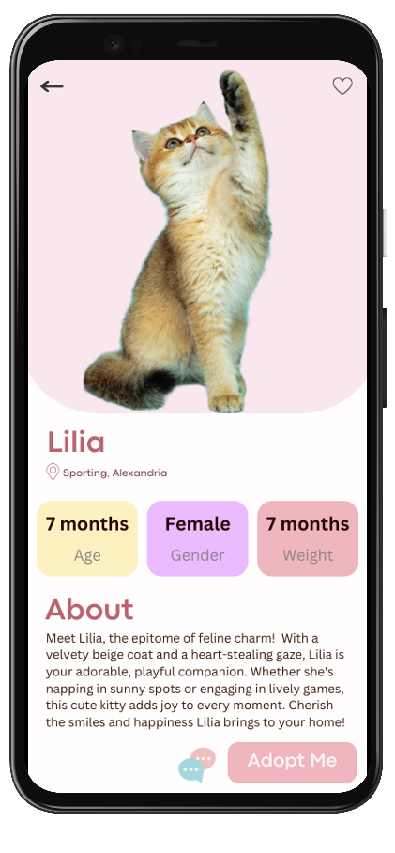

**Animal Profile Activity:**

Retrieves detailed profile information for a selected animal from the database using Parcelable or Serializable with Intent extras.

Displays the animal's detailed profile in a dedicated Animal Profile Activity.

Includes an option to initiate the adoption process.

User can contact owner by clicking on the owner’s contact information and redirecting to the dialer using Implicit Intent.

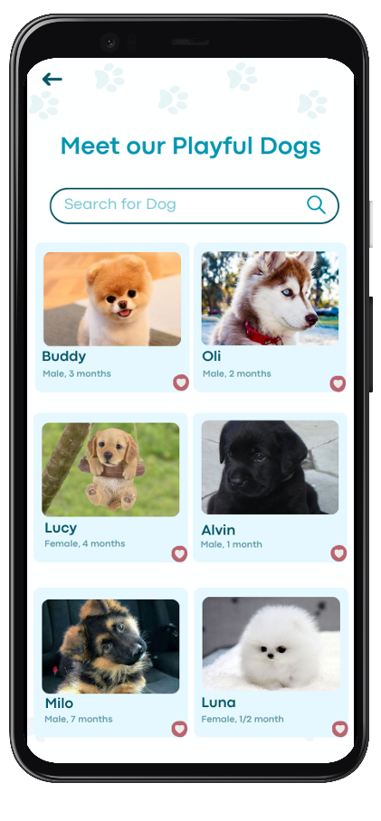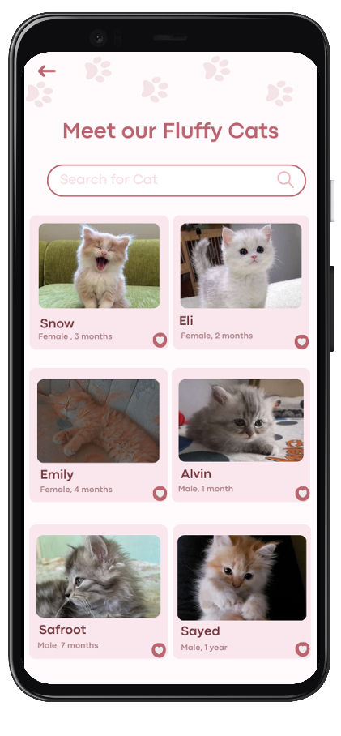

**Pet Display Activity:**

Displays all available pets in a specific category.

Implements search functionality for easy navigation using Intents or ViewModel.

**Upgrades:**



**Chats Activity:**

Sends user chat messages to the database.

Utilizes a real-time messaging system on the server.

Displays a list of ongoing chats for the user.

**Single Chat Activity:**

Retrieves and displays the chat history between users.

Implements real-time updates for new messages.

Includes an input field for sending messages.

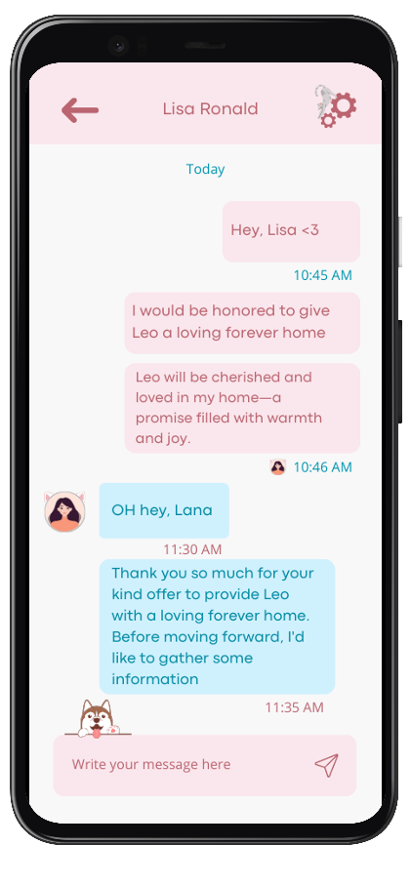

**List Your Pet for Adoption Form Activity:**

Collects information about the pet for adoption and stores it securely in the database.

Pet is then displayed for other users to adopt.

Updates the user's profile to include the newly listed pet.

**Methods and Techniques for Data Transfer:**

* Use Shared Preferences for storing user profiles, login sessions, and preferences.
* Implement ViewModel and LiveData for consistent and updated data sharing across the app.
* Utilize Intent Extras to pass data between activities.